Advertisement in Christian Ethics by [Dr H. Martensen](https://www.google.com/search?tbm=bks&q=inauthor:%22Dr+H.+Martensen%22&sa=X&ved=0ahUKEwjaza_x0LfaAhUB4IMKHUkjDUAQ9AgIMTAB) - 1882

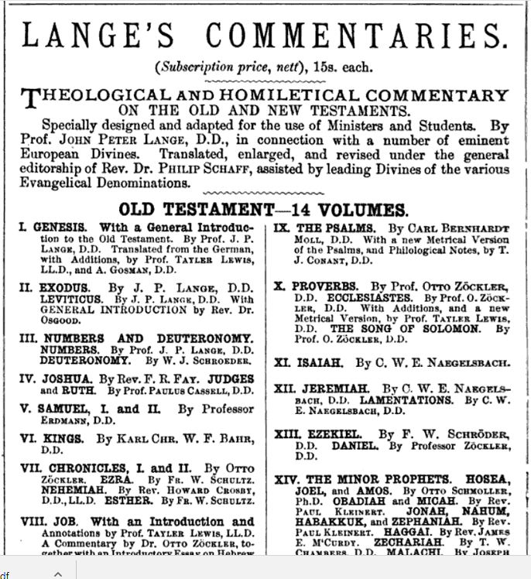

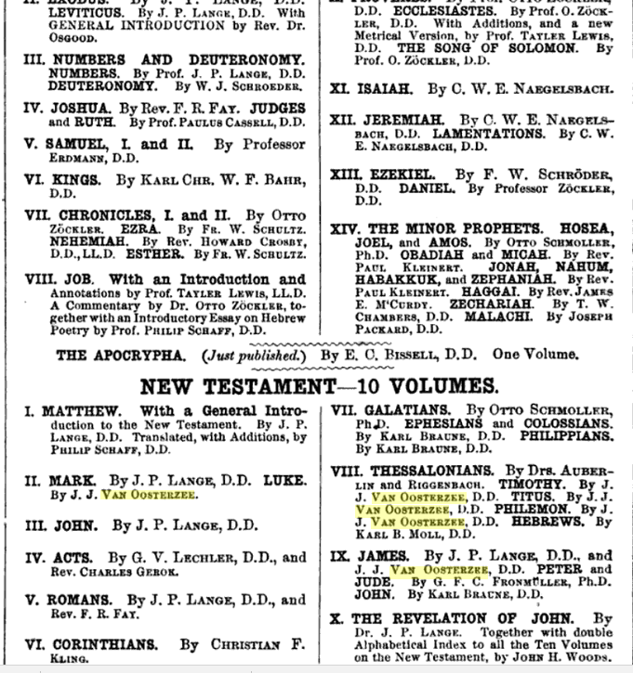

And from 1879 …



