https://www.dbnl.org/arch/_ger003193701_01/pag/_ger003193701_01.pdf It has the Lindeboom quote on p. 84 of the pdf.
Or try this version with translate, probably includes other years? https://translate.google.com/translate?hl=en&sl=nl&u=https://anzdoc.com/de-gereformeerde-school.html&prev=search

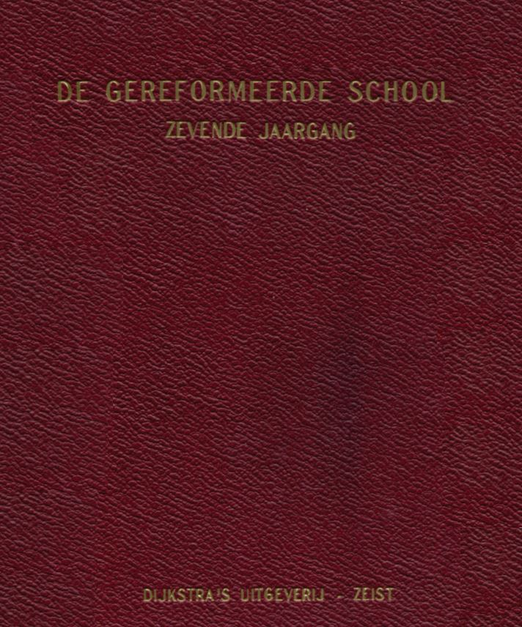
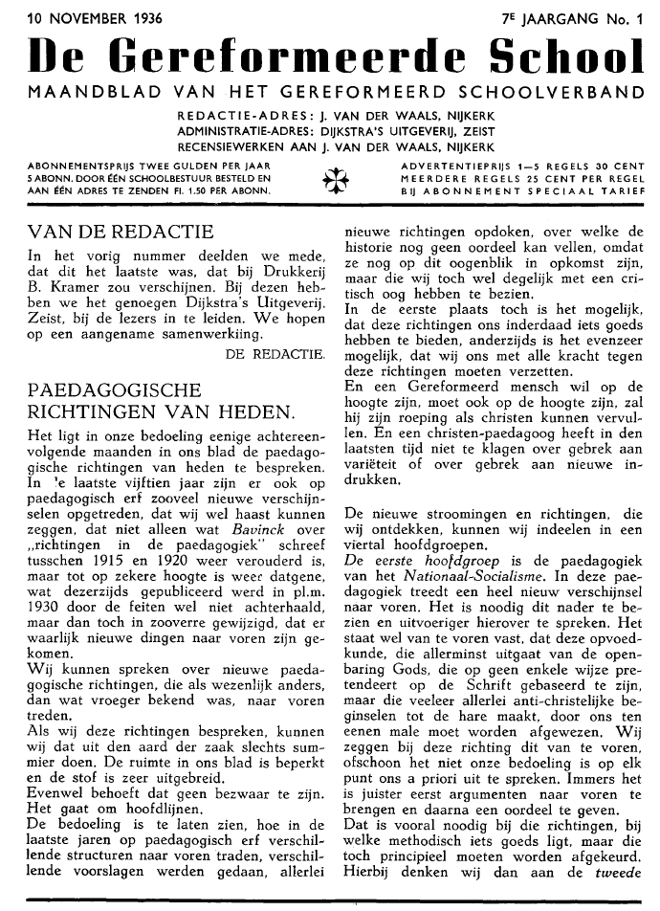
THe Reformed School MONTHLY SHEET OF THE REFORMED SCHOOL RANGE EDITORIAL ADDRESS: J. VAN DER WAALS, NIJKERK ADMINISTRATION ADDRESS: DUKSTRA'S EXHIBITOR, REQUIRES REVIEW WORKS TO J. VAN DER WAALS, NIJKERK SUBSCRIPTION PRICE TWO GOLDS PER YEAR 5 ABONN. ORDERED BY A SCHOOL BOARD AND SENT TO AN ADDRESS Fl. 1.50 PER ABONN.
FROM THE EDITORIAL In the previous issue we announced that this was the last one that would appear at Drukkerij B. Kramer. With these we have the pleasure of Dijkstra's Publishing. Zeist, to introduce readers.We hope for a pleasant cooperation. EDITORS,
PAEDAGOGICAL DIRECTIONS OF PRESENT. It is our intention to discuss the pedagogical directions of today for some consecutive months in our magazine. In the first fifteen years, so many new phenomena have occurred on the pedagogical estate, that we can almost say that not only what Bavinck wrote about "directions in pedagogy" between 1915 and 1920, but to some extent is again that which was published on this side in pl.m. 1930 by the facts is not outdated, but then in so far altered, that there are truly new things have emerged. We can speak of new pedagogical directions, which emerge as essentially different from what was previously known. If we discuss these directions, we can only do so summarily. The space in our magazine is limited and the material is very extensive. However, this need not be a problem. These are main lines.The intention is to show how different structures emerged during the last years on paedagogisch erf, different preliminaries were made, all kinds of

