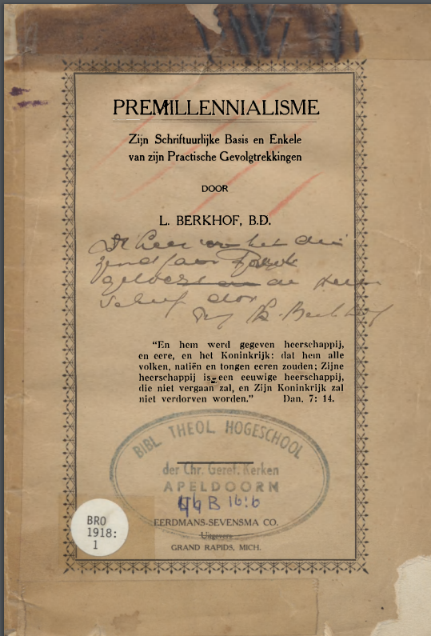
- Jaar: 1918
- Plaats: Grand Rapids, Mich
- Uitgever: Eerdmans-Sevensma
- Bestand: Download PDF (6.14 MB)

Translated through Google Translate to get a general impression, not a precise understanding.
p. 46
… then they had to complete the typical element of Scripture
to deny. Since Premillennialists actually
to make an absolute distinction between the two
parts of God's Revelation, it surprises us
not that Saphir can no longer find himself in the
ordinary names, Old Testament and New Testament,
and would prefer to speak as one of the one
the book of the Kingdom, and of the other, as
the book of the Church. * (5) And if it is true, that it is
Old Testament only relates to the Jews,
then we can hardly scold them, those with
Schleiermacher and his followers to it, as
a Jewish book, all normative authority for the Church
to deny Jesus Christ; and then we have to
also New Testament chants as soon as possible
in place of our Old Testament
psalms. Why would we rather sing
of the temporary peace and prosperity of Israel
then from the eternal blessings of the Church of Jesus
Christ? Why rejoice in the future
earthly glory of God's old people, while
yet our own glory is much greater and
will be heavenly in nature?
There is another point that requires our attention here,
that is, Premillennialism with its absolute separation
between Israel and the Church, progressive
character of God's work of redemption and of being
Revelation completely loses sight of. The fact that
God the redemption of man in an organic way
* Saphir, The Divine Unity or Scripture, pp. 172-174.

p. 47
brings about, naturally means that in that
work progress is from a small insignificant beginning,
through different stages of development,
until the final completion. And we find the revelation
of this progressive work in the Holy One,
Scripture. We cannot go into details here
demonstrate, however attractive the task may be;
and therefore we only point out the fact that we are
especially in the later prophets find indications
of a further development in three directions. In
the first place they point forward to a time,
in which the particularism of the Old Testament
will disappear in the universalism of a better
day, if not only Israel, but also the nations of it
world will share in the blessings of Abraham.
In the second place we already notice it in them
flash of the day in which religion no longer
will be a matter of the nation as a whole, but rather
of the single person; when the personal
responsibility will come to the foreground
steps, and the big question will no longer be that of
a person's relationship to some special one
nation, but that of the personal relationship
the soul to God. And finally they already contain
clear indications that the religion gradually
be stripped of his external ceremonial
shapes and in his true spiritual character
will come to light. Now we are turning from the
Prophets to the New Testament, we see
because these promises are fulfilled, that higher position
p. 48
reached, and the Old Testament button unfolded
to a delicious flower.
However, what is the position of the
Premillennialism? If we then turn to
the New Testament, we suddenly see ourselves
placed for a completely new phenomenon, of which
the prophets had no knowledge whatsoever,
namely the Church of Jesus Christ. Even the old
the federal people were in no way at her foundation
prepared, and we cannot blame them
to assume that they did not accept the Messiah, where
He accomplished a work of which the prophets
had not spoken, and undid what they as
had designated the special task of the Messiah.
The Church is here for us as the embodiment
of a thought that first emerged later.
She is only one to the word of Guers
kind of parenthesis (tusschenzin) - well a delicious one
parenthesis-but only a parenthesis. *
It does not represent a further development
of the work of redemption, but a temporary deviation
of the straight line, in which God his work
position. Speaking in the language of motorists,
we would say that God is in the present
make a detour.
To the disbelief of the Jews, He thought it necessary
to leave the smooth roads on which He rode in the old dispensation;
now He does not follow without greatness
difficulty the sinful and dusty ways of the
p. 49
dispensation of the Spirit; and He will be the royal army
not reach until finally the Millennium ushered in.
We see the Premillennialists refer back to
the Judaic ideal. The prophets will be theirs
fulfillment in a restored Kingdom of
Israel and in a rebuilt temple with whole
ceremonies service. The revelation of animal fulfillment
wait for us in the future. It is true the Gentiles
can also share in the future glory
of the Kingdom, but only if she
Israel be incorporated. Is this not the error of
Judaics from Paul days? And just like that old one
false teachers, also do the Chiliasts, while they do
Israel honor high, the Christ actually-clean
perhaps unconsciously-dishonor. Gal. 5: 2 ff. (6) Not
the world but Israel, is the ultimate goal of history
of redemption; an earthly kingdom
the inception of a spiritual people, it is wonderfully ideal!
And this kingdom will not be established by
moral agents, as e.g. the preaching of it
Gospel, nor by such workings of the Holy
Spirit in the hearts of men as we are
to experience the present dispensation-those means
are completely inadequate; but by great judgment
at the end of the world, by an external
supernatural power. * The emphasis is shifted
in the work of redemption from the first on the
second coming of Jesus Christ; and the spiritual one
p.50
(?) he work of the Savior in the dispensation of the
Gospel is being reduced. Once again, the Chiliasm
is blind to the progressive nature of the work
of redemption and of corresponding thereto
Revelation. It despairs the present
world, and finds its only comfort in it
view of the Millennium.
My fourth and final point of criticism is focused
against the distinction, which the Premillennialists
make between the Kingdom and the Church in the
New Testament; and against the resulting
denial of the present kingship of
Christ. We are told that the Messiah, then
He came, really had the plan, for his Kingdom
to be founded, but was retained
the unbelief of the Jews. It will still be erected,
but not until the Christ returns. Instee
of the Kingdom, Christ has founded his Church,
those in distinction from the Kingdom one
spiritual organization. And He is not of this Church
the King, but the divine Head. Possibly possible
He also now be considered a King, but
then only as a King without a Kingdom.
Gray says: Christ considered his human
nature, Christ the God-Mench, reigns on this
moment nowhere. As God, He rules Himself
about the universe, just as He always did
has, since He created it; but as the resurrected

p. 51
and glorified man He is "seated on the right hand
God, further expecting, until his
enemies are made into a foot bank
feet. "(Heb 10: 12-13) In that day, however, when
his enemies are made into his footstool,
He will come again, and "the Lord will give him
the throne of David his father. And He will pass over
to be the house of Jacob's King forever. "
(Luke 1: 32, 33). *
But what teaches us about the New Testament
these businesses? To clear education,
that it gives us, is the Kingdom of God both
present and future. It is nowadays
as a spiritual reality, visible only before
the eye of the born again, as an organic one
planting, and as an all-pervading force,
Matt. 6: 33; 13: 31-33; 16: 28; 24: 34; Luke 17: 20,
21; Joh. 3: 5; Rev. 1: 6. Until the time of
John the Baptist was the subject of the
prophecy; from his days on, however, it is it
theme of Gospel preaching, Matt. 11: 11-13;
Luke 16: 16.f And this Kingdom is, though not entirely,
but still be identical to a certain extent
with the Church. In the Church the Kingdom obtains
a visible shape; the believers are at the same time
time members of one person and citizens of the other.

p. 52
Dr. Vos says: "The Church is a form that the Kingdom
assuming as a result of the new
stage, which is the Messiahship of Christ
with his death and resurrection. As much as the
expansiveness of the membership, Jesus teaches
clear to us, the invisible Church and the Kingdom
to identify. "* That these two to
a certain height are identical, we also see from it
next: (1) In Matth. 16:18, 19 are the names
"Church" and "Kingdom of God" apparently synonymous.
The intimate connection, in which these verses come to each other
standing, the image of a house that underlies both
lies, and the fact that Peter was appointed to
home carer in the Kingdom (so it is
nowadays was in his time), ensuring it
conclusion.f (2) At the convent in Jerusalem says
James, the brother of the Lord: "Men brothers
! hear me! Simeon has told how God
first visited the Gentiles, to get from them one
to accept people for his name; and with this
agree with the words of the prophets
It is written: After this I will return, and
rebuild the tabernacle of David, which is decayed
is, and rebuilt that which is broken,
and I will rebuild it, that the
peoples seek the Lord, and all
p. 53
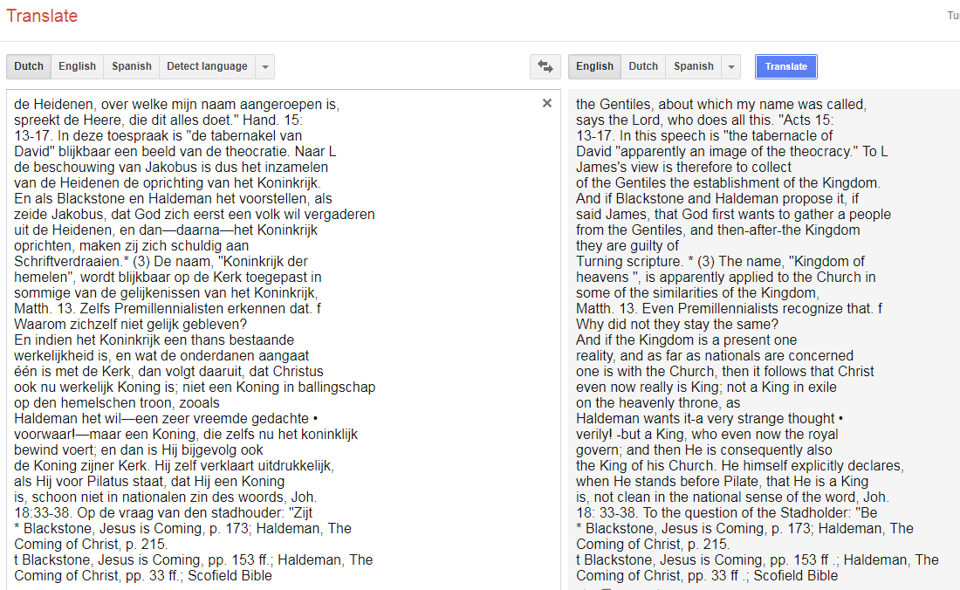
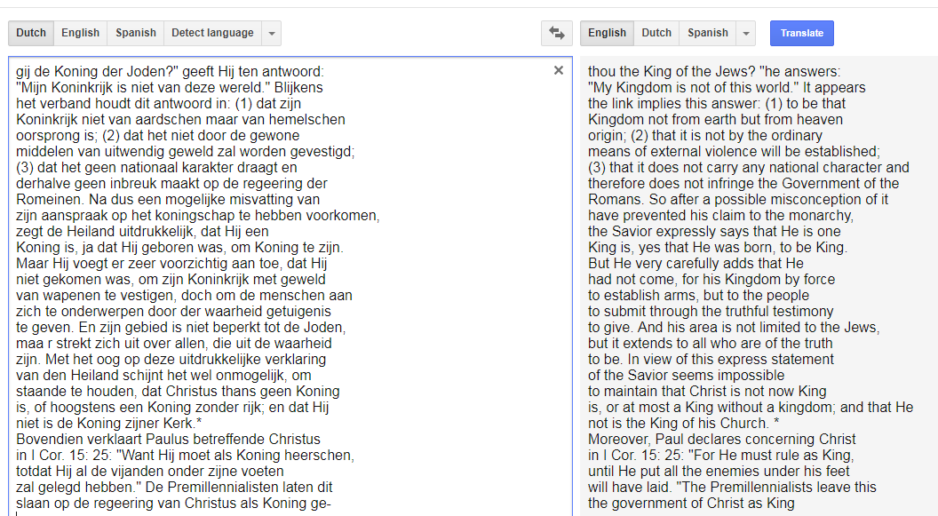
* See the comments of Godet, Zahn and Van Andel (and W. Blackstone was also cited above)

skipping down to the end of his appendices for his mention of Van Andel:

(7) It may be useful to point here
at the position of Rev. J. Van Andel, a man who is as general
known, had Chiliastic tendencies, and which nevertheless
Writer in high esteem was in Gereformeerde [Reformed]
circles, both in the Netherlands and in our own country. His predilection
for Chiliasm clearly appears to be Sacred
History, p. 488. But we must not think that he
would also endorse such Chiliastic strangeness,
like that Israel and the Church of the Lords of the New Testament
not together formed the one people of God; that it
Kingdom and the Church are absolutely distinct; and that
Christ is not the great King of his Church. Just it
contrary! Thus we read in his, Paul’s Epistle to the Romans,
p. 220: "They are not a tree (the believers of the
New Testament) planted next to Israel's tree, but in
these branches included, they are the continuation of the
tribe, connected to the root, fed by the spirit of life
from the tree, and sharing in the tree given to the tree
blessing. "See also, Paul's Gospel, p.
He explicitly teaches that the Kingdom of God is a present
reality is in the hearts of believers. Listen
to what he says on p. 90, 91 of his, Jesus' doctrine: "Asked
being of the Pharisees, when the Kingdom of God
come, he says, that it does not come with outward appearance,
actually, under observation, Luke 17: 20, that is, through sensual
signs, which were observed with the eyes of the flesh
become, it does not announce its arrival. Honor one
it knows it is in our midst, as an unseen force,
carried by persons whose appearance does not betray them,
and seated wherever, on the basis of personal
reconciliation the divine government has been restored
Before all He directs, by spiritual means only, with
rejection of oak-flesh stimulus, his dominion
in the secret of the heart; only later he gives his
rich the appropriate figure of the empire, which it in its full glory
appear before all eyes. To have
that we should thus take the realm as a spiritual one
power, yet we must not think that it is without intervention
of human means, or
that it would all take shape before his revelation in glory
to miss. On the contrary, his appearance presupposes labor
his servants, the preaching of the word, the service of the
sacraments, the presence of churches, all of them
things that belong to the visible. "
Read on, what he says concerning the testimony of
Jesus before Pilate: "Jesus recognizes that He is one
Kingdom has, and servants who are in his service.
But with recoil on the question whether he is the King of the Jews,
He says that his kingdom is not of this world, that
Pilate was not allowed to think, that are accused pregnant
went from the plan, to the Emperor as a Jew
to let the king proclaim. His Kingdom is in this
world, but it is not of this world, neither now nor
later on. " Gospel of John, p.361. [see John 18:36 ]

Here are some cut and paste of image screenshots, they could be run through an OCR to generate text.
Henry Zwaanstra, “Louis Berkhof,” in David F. Wells, ed., Reformed Theology in America
(Grand Rapids: Eerdmans, 1985), p. 159-161.
https://books.google.com/books?id=S_ja7y27VYsC&pg=PA170&dq=Henry+Zwaanstra,+%E2%80%9CLouis+Berkhof,%E2%80%9D+in+David+F.+Wells,+ed.,+Reformed+Theology+in+America&hl=en&sa=X&ved=0ahUKEwjJ2dS63qTeAhVF5awKHdWiDXcQ6AEIPDAE#v=onepage&q&f=false
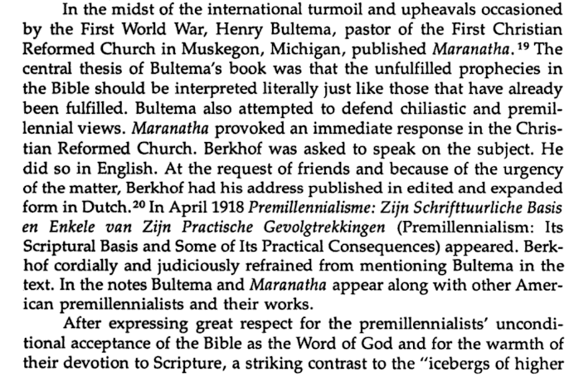
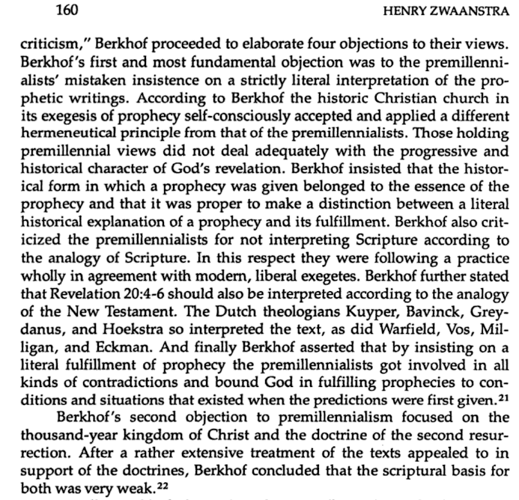
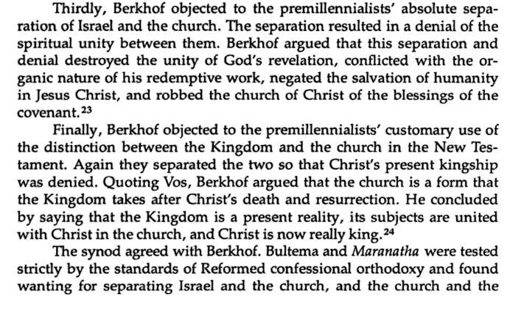
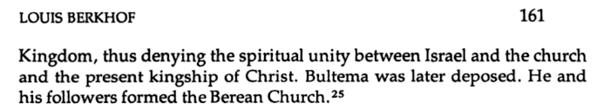
The end notes were not included within this Google Books excerpt.

Here is a 2009 paper by Geoffrey Randall Kirkland on Berkhof; http://vassaloftheking.com/home/180007755/180007755/Images/Paper%20-%20Berkhof%20-%20Theologian%20and%20Theology%20by%20Geoffrey%20Kirkland.pdf
It cites Zwaanstra and another source on the topic (p. 20) was Berkhof’s Second Coming, p. 93.
“In view of all this it is a conundrum to me how they who belong to the Church, for whom the promises given to Israel do NOT at all apply, can derive special comfort from the fact that Jesus at his return will establish a temporal Jewish kingdom on earth; how they can find it a specially consoling thought that Jesus, who after his resurrection was already endowed as Mediator with an endless life and as such could not remain in this sinful world, but had to ascend to heaven, will after his return again dwell on earth for a thousand years in a world in which sin and death still hold sway; and how they can find it a cause for special rejoicing that Christ will again have to descend from his heavenly throne for a prolonged stay on earth, which is still under the curse of sin and death and still a scene of wickedness and lawlessness, of sickness and sorrows; and that with him his saints will also for a thousand years have to exchange their heavenly bliss and glory for an environment that is not at all suited to their glorified conditions. In the light of all these considerations it becomes very difficult to explain the supposedly unique comfort of the dispensationalists.” From the next sentence; “Berkhof says that ‘the New Testament never says anything about the restoration to that ancient covenant people.’”

But to really see what Berkhof said on Premillennialism, go to his Systematic Theology section about it.
https://archive.org/stream/SystematicTheology/93884037-Louis-Berkhof--Systematic-Theology_djvu.txt
I. Millennial Views

There are some who connect with the advent of Christ the idea of a millennium,
either immediately before or immediately following the second coming. While this idea is
not an integral part of Reformed theology, it nevertheless deserves consideration here,
since it has become rather popular in many circles. Reformed theology cannot afford to
ignore the wide-spread millenarian views of the present day, but should define its position
with respect to these. Some of those who expect a millennium in the future hold that the …
Searching for the word ‘spiritualize’ there gives an example of what Berkhof meant; “This national idea [of Israel] is naturally very prominent in the Old Testament, but the striking thing is that it did not disappear when the nation of Israel had served its purpose. It was spiritualized and thus carried over into the New Testament, so that the New Testament people of God are also represented as a nation, Matt. 21:43; Rom. 9:25.26,” etc. So in this example the Church does inherit from Israel certain shared characteristics.
This example probably doesn’t answer the question of what does the CRC mean when it spiritualizes the promises made to Israel, but in general it is clear the promises are fulfilled through the Church.
Another biographer said of him, “Berkhof believed from Vos that the church is the form the Kingdom took …” (Thomas, Geoff -Banner of Truth Article, March 28, 2008).

