Are the origins of a main Zeeland church still known today? Why did they secede and start up in 1882?
Source: The Jewish Era, a publication of William E. Blackstone’s Chicago Hebrew Mission in July, 1894.
Revs. Fles & Riemersma had already witnessed at that Mission during the Chicago World’s Fair in 1893, which is from same source (on their p. 247.)
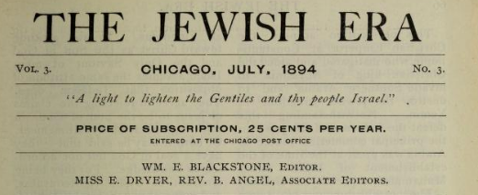

p. 69 (article is from Blackstone – he was sometimes called the Father of Christian Zionism).
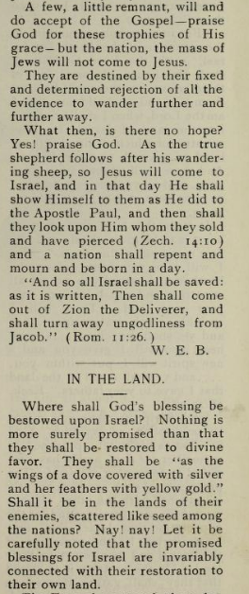 … The bottom part is also by Blackstone.
Biography of Rev. John I. Fles, North Street CRC’s first minister, begins on p. 70. It was written by North Street CRC’s second minister, J. Riemersma. The article ends on p. 73 with a quote from Rev. Fles:

“Yes, it is true, Jesus will come to His people and they will mourn over Him as over an only son, and Israel will believe in Him and walk in the ways of truth and peace, and all the earth will be a Lord’s Garden and Jesus will reign as the King of all nations.”

https://archive.org/stream/amfmonthly1518amer#page/n357/mode/2up/search/%22John+Izak+Fles%22
His biography by Kenneth Fles is available for free downloading at http://www.stickysystems.com

