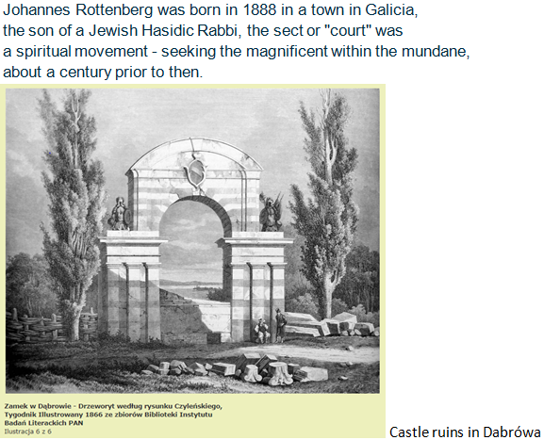 | 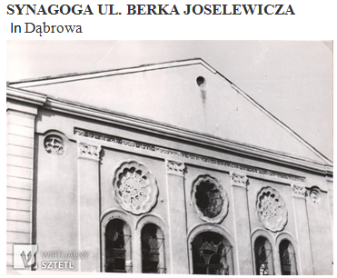  https://kehilalinks.jewishgen.org/dabrowa_tarnowska/
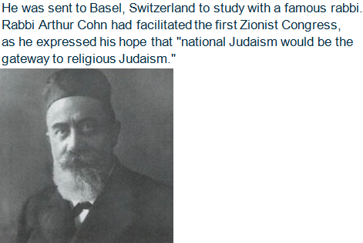 | 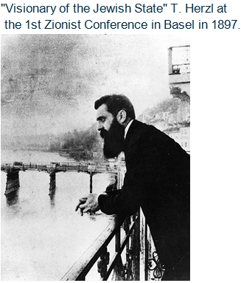
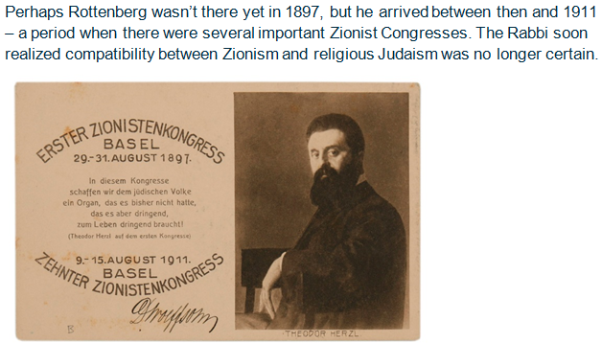 | 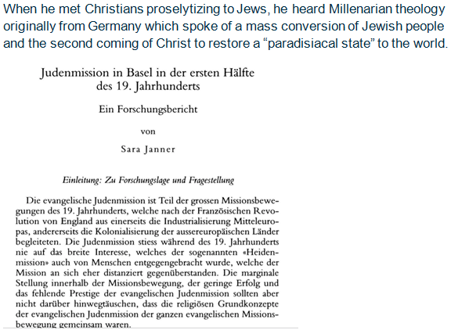

 | 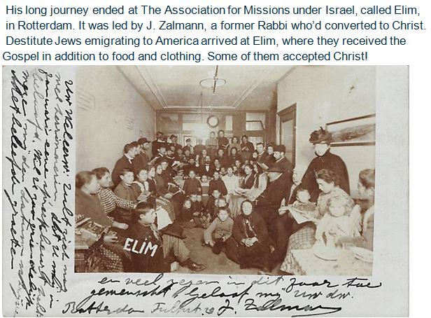
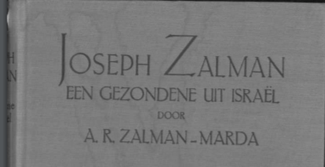 Translated from this biography:  One day Missionary Zalman called me into his house office.  He had a letter for me, and already I recognized my father's handwriting. No wonder I nervously devoured the contents.  My father had heard that I was going astray, and was even in  the house of a "renegade." The letter made warnings and threats.  I immediately replied that he should not worry, I would not do anything or be persuaded into any conviction unless fully assured  of the truth. I earnestly examined the Scriptures … | 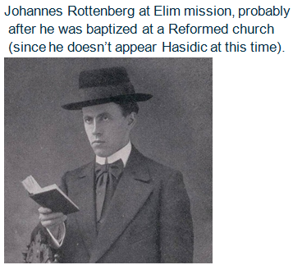

One biography said, “Rottenberg was one of the most gifted and important theologians of Jewish descent in the Netherlands. He was rooted in the Talmud and in the Jewish tradition and had a solid knowledge of the rabbinic commentaries on the Bible. Therefore,  he was able to discuss the Messiah with rabbis on an equal level.”  He’d now also studied the New Testament.  He was quite astute when he likely saw the impending storm coming  to Europe. He boarded the S.S. Noordam and arrived at Ellis Island, N.Y. on July 14, 1914. The Great War began two weeks later.  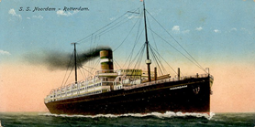 | Rottenberg probably had his destination already in mind.  The next stage of his spiritual and literal journey continued  to develop his interest in Zionism. He would now seek the  Chicago Hebrew Mission and its founder, W. E. Blackstone  – sometimes called the father of Christian Zionism. In 1891  Blackstone had played a leading part in crafting a petition for  the rebuilding of a new Jewish state in the holy land, Palestine.  https://fromthevault.wheaton.edu/2020/07/01/to-show-kindness-to-israel-william-blackstones-memorial/  It’s possible he may have heard of J. I. Fles, a minister with a  Dutch Jewish background whose CRC denomination supported  the Chicago Hebrew Mission. The CRC Jewish mission was  closely following Elim’s work before the war. Fles held similar  premillennial beliefs.
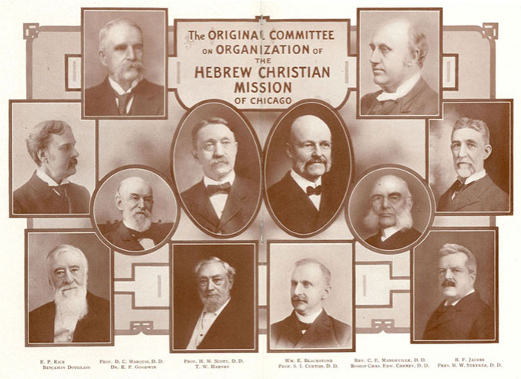 | From “The Jewish Era” in American Messianic Fellowship, 1915  (It also mentioned the Pastor Dolbeck who had baptized Rottenberg.  He published a missionary magazine in German titled “Zion’s Friend”)  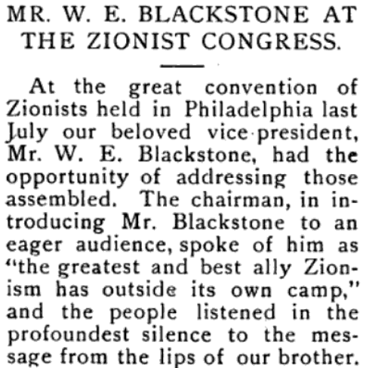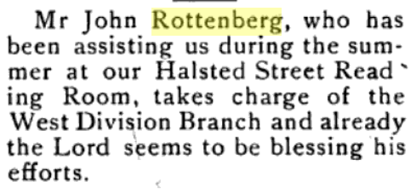
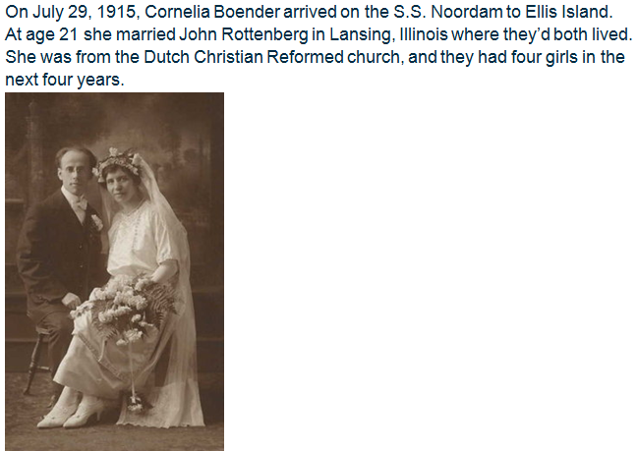 | Rottenberg continued his studies at Moody Bible Institute, elsewhere in Chicago, and he went to the CRC’s seminary in Grand Rapids, MI, in 1917 and graduated in 1920.  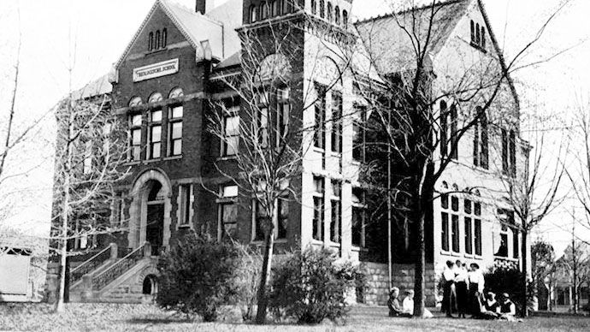

During this period (after the Balfour Declaration declared in favor of a Zionist state), the CRC Synod decided to end their support for the “interdenominational” Chicago Hebrew Mission and to begin a different “ecclesiastical and confessional” Chicago Jewish Mission “of our own Church.”  They were probably concerned that Blackstone’s premillennial eschatology did not conform to their amillennialist view of the end times. Rottenberg then worked at and in 1922 he led the denomination’s new mission there. The work is difficult and discouraging.  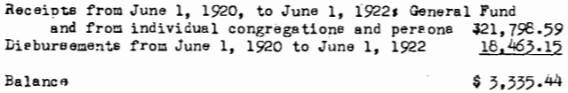 | In 1924 Rottenberg and family move to London, and he worked at the Hebrew Christian Testimony to Israel mission, led by Messianic Jews, David Baron and Dr. Schönberger. His first son Isaac was born, and they named another son after Baron.  Rottenberg would write this obituary of Baron.  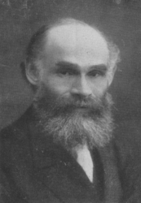
Rottenberg is called back to Rotterdam to lead the Elim Mission in 1929. He continues his work passionately, with speaking engagements throughout the country.  He gives baptismal instruction, and leads home circles.  A “remarkable” number of Jews turned up for his “dialogues.”  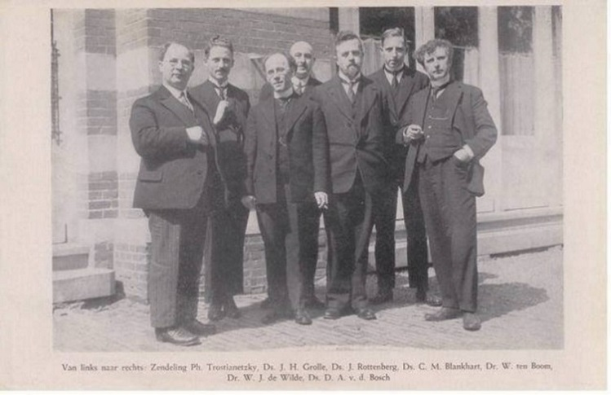  The seven speakers of the first annual Jewish conference in 1930. Rottenberg is third from the left. Third from the right is Rev. Wim ten Boom, the brother of Corrie ten Boom, he wrote “The awakening of the Jewish people.” The “Federation of Dutch Missionary Societies Working Among the Jews” began in 1935. | The mission receives donations from Christian congregations, such as that of Rev. D.A. van den Bosch, Reformed minister in The Hague (on the right of picture.) He was a member of a “Confessional Association” (translated), which had been opposed to Reformed Church liberalism and modernism since the 1860s. Rev. van den Bosch is concerned for the Jewish people, based on his (premillennial) “expectations for Israel.” He was arrested in 1940, and then sent to Camp Amersfoort in 1941. He clandestinely preached from Daniel 6 to other prisoners. On March 20, he took his last breath, aged 57.  https://twnews.nl/nl-news/ds-dirk-arie-van-den-bosch-bloedgetuige-in-kamp-amersfoort
The Rottenberg family moved to Scheveningen so he can preach in the Hague, especially in 1940-41. He publishes a missionary magazine, and writes several books in the thirties. Rottenberg traveled through Germany and Poland in 1935. He wrote against Nazis. “Christians must endure such persecution,” he wrote. They had already gone back to the Chicago area to visit Cornelia’s family. He is asked to return to Chicago and translate the New Testament into Yiddish. He had planned to do so. But then in January 1942 …  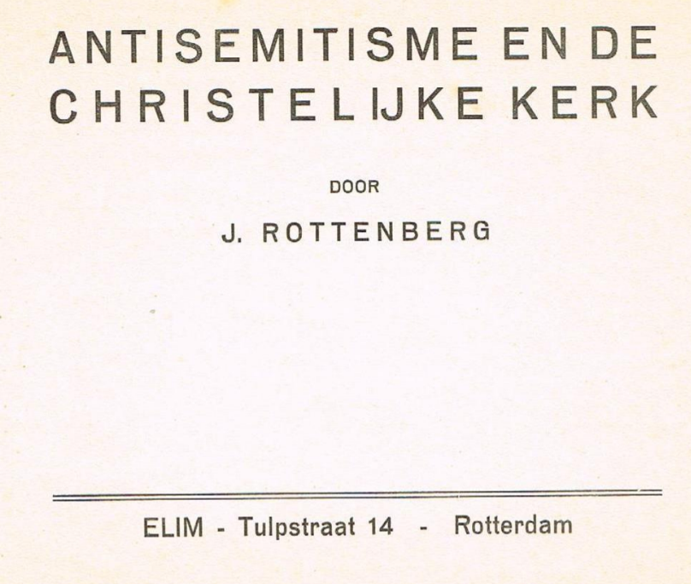 1931. “The pastor of the Second xxxxxx Church (in New York) wants to destroy our Jewish faith. The Jewish God is a thorn in his side… We Jews are besieged.” | The Battle of Rotterdam began on May 10th, 1940.  In January 1942, Rev. Rottenberg was arrested and  taken to Amersfoort concentration camp. He would  not stop praying with the other prisoners.  In June 1942, John Rottenberg died at 62 years  of age in the brutal labor camp in Mauthausen, Austria.  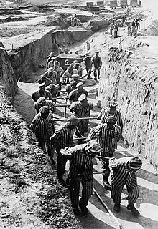
Other members of the Rottenberg family (not sure who), and workers from the Elim Mission were imprisoned, e.g. S. P. Tabaksblatt was deported to Theresiënstadt in 1944 (per the Dutch Hadderech).  He survived. He was confirmed in 1953 as a minister in Bethlehem Church in The Hague. That year he said Herzl’s Zionist ideal had become a reality. Isaac Rottenberg would later marry his daughter, and then follow in his father John’s footsteps.  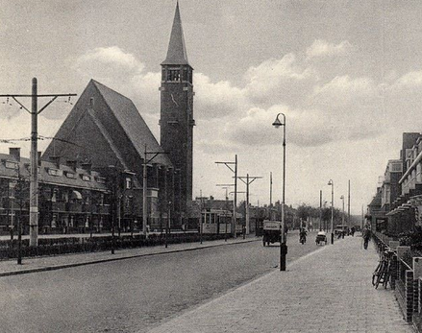  And now? A recent story told of an attack during Hanukkah on Hasidic Rabbi Chaim Rottenberg (not sure if he’s related). It ends; “While Rabbi Rottenberg is calling for healing, security is still a concern. There is a state trooper posted in front of the synagogue next door to his home as well as other temples in the area. And that will be the case for the unforeseeable future.” | This is how I like to remember, to know how Rev. Rottenberg saw the future of his people. Israel’s Herstel (Restoration) cited the 3rd chapter of Hosea and Romans 11 to say in Dutch, “ … And when that glorious time of the Messianic Kingdom of Peace [Shalom] comes, when the believing Gentiles are grafted in, and the believing Jews are grafted in again into that olive tree, then it will be one Church of the living God, one people Israel through faith in Jesus Christ, and then with common rights to the promises; not only of Palestine, but also of the inheritance of the whole earth.” (Per Mrs. A.R. Zalman-Marda)  Rev. Rottenberg's biography, " Sent and Recalled,” by Mrs. A.R. Zalman-Marda (wife of the missionary). It's from chapter 19, Israel's Restoration. I’ve only found the excerpt linked above.

